**IAM JAVA ASSIGNMENT 1**

1. public class Main

{

public static void main(String[] args) {

System.out.println("Hello World");

System.out.println("Anitta");

}

}

Output:

1. import java.util.Scanner;

public class Main

{

public static void main(String[] args) {

int a,b;

Scanner s = new Scanner(System.in);

System.out.println("Enter 1st number: ");

a=s.nextInt();

System.out.println("Enter 2nd number: ");

b=s.nextInt();

int sum = a+b;

System.out.println("Sum of 2 numbers = "+sum);

}

}

Output:

3.) import java.util.Scanner;

public class Main

{

public static void main(String[] args) {

int a,b;

Scanner s = new Scanner(System.in);

System.out.println("Enter 1st number: ");

a=s.nextInt();

System.out.println("Enter 2nd number: ");

b=s.nextInt();

int div = a/b;

System.out.println("Division of 2 numbers = "+div);

}

}

Output:

4.,8.,9.) import java.util.Scanner;

public class Main

{

public static void main(String[] args) {

System.out.println("-5 + 8 * 6 = "+ -5 + 8 * 6);

System.out.println("(55+9) % 9 = "+ (55+9) % 9);

System.out.println("20 + -3*5 / 8 = "+ 20 + -3*5 / 8);

System.out.println("5 + 15 / 3 * 2 - 8 % 3 = "+ (5 + 15 / 3 * 2 - 8 % 3));

System.out.println("((25.5 * 3.5 - 3.5 * 3.5) / (40.5 - 4.5)) = "+((25.5 * 3.5 - 3.5 * 3.5) / (40.5 - 4.5)));

System.out.println("4.0 * (1 - (1.0/3) + (1.0/5) - (1.0/7) + (1.0/9) - (1.0/11)) "+ 4.0 * (1 - (1.0/3) + (1.0/5) - (1.0/7) + (1.0/9) - (1.0/11)) );

}

}

Output:

5.) import java.util.Scanner;

public class Main

{

public static void main(String[] args) {

int a,b;

Scanner s = new Scanner(System.in);

System.out.println("Enter 1st number: ");

a=s.nextInt();

System.out.println("Enter 2nd number: ");

b=s.nextInt();

int prod = a*b;

System.out.println("Division of 2 numbers = "+prod);

}

}

Output:

6.) import java.util.Scanner;

public class Main

{

public static void main(String[] args) {

int a,b;

Scanner s = new Scanner(System.in);

System.out.println("Enter 1st number: ");

a=s.nextInt();

System.out.println("Enter 2nd number: ");

b=s.nextInt();

int sum = a+b;

int sub = a-b;

int prod = a*b;

int div = a/b;

int mod = a%b;

System.out.println("Sum of 2 numbers = "+sum);

System.out.println("Difference of 2 numbers = "+sub);

System.out.println("Product of 2 numbers = "+prod);

System.out.println("Division of 2 numbers = "+div);

System.out.println("Modulus of 2 numbers = "+mod);

}

}

Output:

7.) import java.util.Scanner;

public class Main

{

public static void main(String[] args) {

int a;

System.out.println("Enter the number: ");

Scanner s = new Scanner(System.in);

a = s.nextInt();

for(int i=1;i<=10;i++){

System.out.println(a + "*" + i +"=" + a*i);

}

}

}

Output:

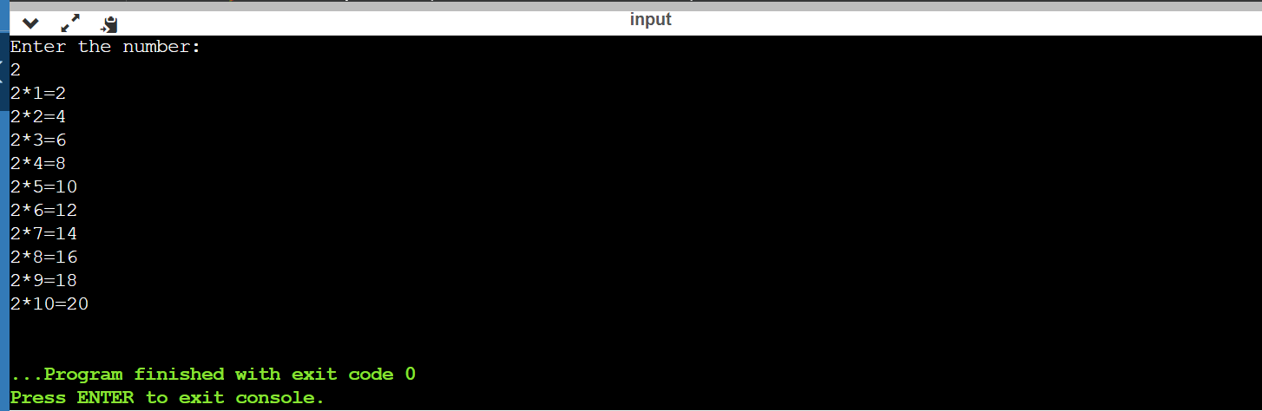

10.) import java.util.Scanner;

public class Main

{

public static void main(String[] args) {

float r;

System.out.println("Enter the raduis: ");

Scanner s = new Scanner(System.in);

r = s.nextInt();

System.out.println("Perimeter of the circle = "+ ( 2*3.14*r));

System.out.println("Area of the circle = "+ (3.14*r*r));

}

}

Output:

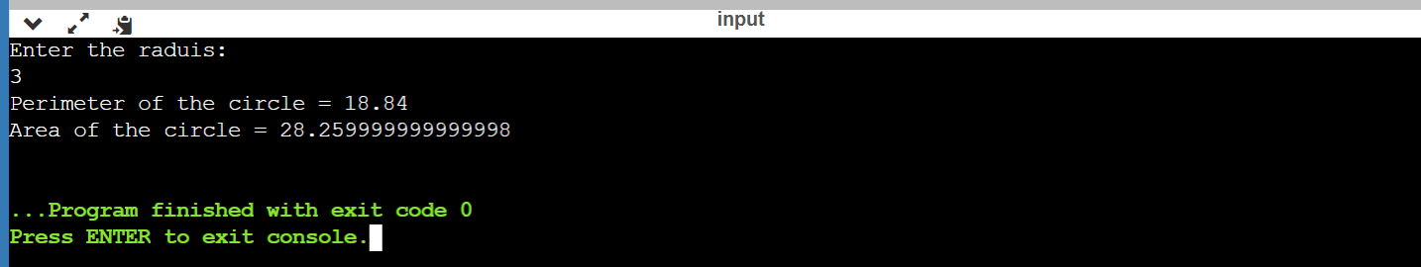

11.) import java.util.Scanner;

public class Main

{

public static void main(String[] args) {

float a,b,c,avg;

System.out.println("Enter the 1st number: ");

Scanner s = new Scanner(System.in);

a = s.nextInt();

System.out.println("Enter the second number: ");

b = s.nextInt();

System.out.println("Enter the second number: ");

c = s.nextInt();

avg = (a+b+c)/3;

System.out.println("Average = "+ avg);

}

}

Output:

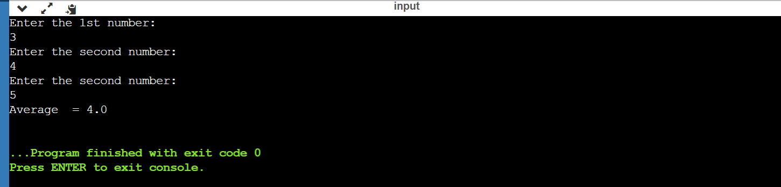

12.) import java.util.Scanner;

public class Main

{

public static void main(String[] args) {

float a,b;

System.out.println("Enter the length: ");

Scanner s = new Scanner(System.in);

a = s.nextInt();

System.out.println("Enter the breadth: ");

b = s.nextInt();

System.out.println("Perimeter of the rectangle = "+ ( 2*(a+b)));

System.out.println("Area of the rectangle = "+ (a*b));

}

}

Output:

13.) import java.util.Scanner;

public class Main

{

public static void main(String[] args) {

int a,b,c;

System.out.println("Enter the 1st number: ");

Scanner s = new Scanner(System.in);

a = s.nextInt();

System.out.println("Enter the second number: ");

b = s.nextInt();

c=a+b;

a=b;

b=c-a;

System.out.println("After swapping value of a = "+ a);

System.out.println("After swapping value of b = "+ b);

}

}

Output:

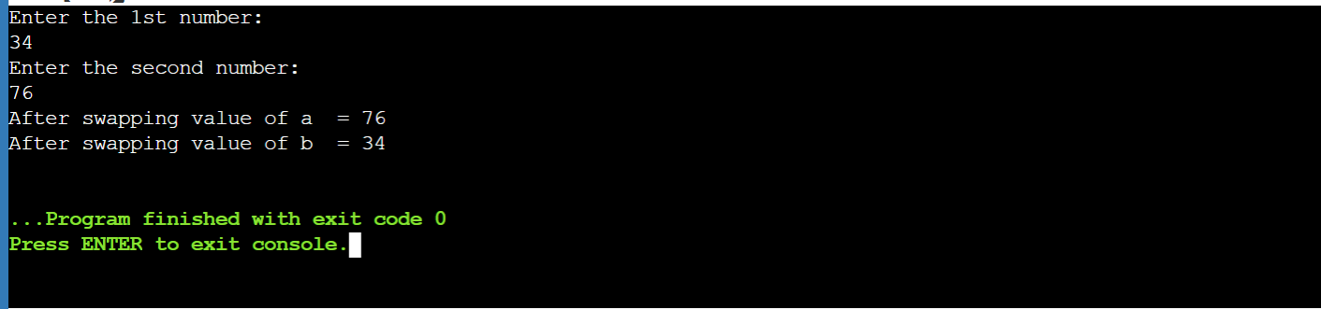

14.) import java.util.Scanner;

public class Main

{

public static void main(String[] args) {

long a,b;

int i = 0, carry = 0;

Scanner s = new Scanner(System.in);

System.out.println("Enter the 1st number: ");

a = s.nextLong();

System.out.println("Enter the second number: ");

b = s.nextLong();

int[] sum = new int[10];

while(a != 0 || b != 0)

{

sum[i++] = (int)((a % 10 + b % 10 + carry) % 2);

carry = (int)((a % 10 + b % 10 + carry) / 2);

a /= 10;

b /= 10;

}

if(carry != 0)

{

sum[i++] = carry;

}

--i;

System.out.print("Sum of the 2 binary numbers = ");

while(i >= 0)

{

System.out.print(sum[i--]);

}

System.out.println();

}

}

Output:

15.) import java.util.Scanner;

public class Main

{

public static void main(String[] args) {

long a,b,prod=0;

int d,f=1;

Scanner s = new Scanner(System.in);

System.out.println("Enter first binary number: ");

a=s.nextLong();

System.out.println("Enter second binary number: ");

b=s.nextLong();

while(b!=0) {

d=(int)(b%10);

if(d==1) {

a=a*f;

prod=bin_product((int) a, (int) prod);

} else {

a=a*f;

}

b=b/10;

f=10;

}

System.out.println("Product of two binary numbers = " + prod+ "\n");

}

static int bin_product(int b1, int b2) {

int i=0,remainder=0;

int[] sum = new int[20];

int result=0;

while(b1!=0 || b2!=0) {

sum[i++] = (b1 % 10 + b2 % 10 + remainder) % 2;

remainder = (b1 % 10 + b2 % 10 + remainder) / 2;

b1 = b1 / 10;

b2 = b2 / 10;}

if (remainder!=0) {

sum[i++] = remainder;

}

--i;

while(i>=0) {

result = result * 10 + sum[i--];

}

return result;

}

}

Output:

16.) import java.util.Scanner;

public static void main(String[] args) {

int dec,q,i=1,j;

int bin[] = new int[100];

Scanner s = new Scanner(System.in);

System.out.println("Enter the integer number: ");

dec=s.nextInt();

q=dec;

while (q!= 0) {

bin[i++]= q%2;

q= q/2;

}

System.out.println("Binary number is = ");

for (j=i-1;j>0;j--) {

System.out.print(bin[j]);

}

}

Output:

17.) import java.util.Scanner;

public class Main

{

public static void main(String[] args) {

int n,i=0;

Scanner s = new Scanner(System.in);

System.out.println("Enter integer number :");

n=s.nextInt();

int[] hex = new int[100];

while(n != 0) {

hex[i] = n%16;

n = n/16;

i++;

}

System.out.println("The hexadicmal equivalent for the number is : ");

for (int j = i - 1;j>=0;j--) {

if (hex[j] > 9)

System.out.print((char)(55 + hex[j]));

else

System.out.print(hex[j]);

}

}

}

Output:

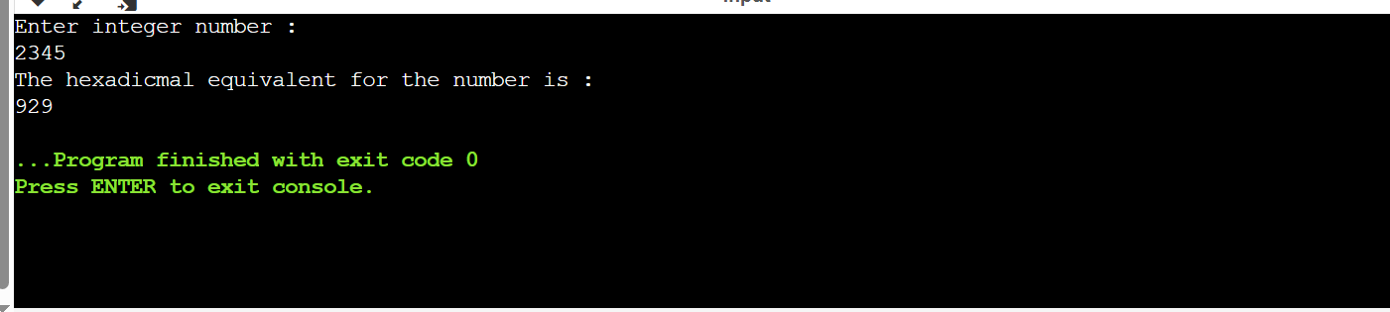

18.) import java.util.Scanner;

public class Main

{

public static void main(String[] args) {

int dec,rem,q,i=1,j;

int oct[] = new int[100];

Scanner s = new Scanner(System.in);

System.out.println("Enter integer number :");

dec = s.nextInt();

q=dec;

while(q!=0) {

oct[i++]=q%8;

q=q/8;

}

System.out.println("The octal equivalent number is: ");

for(j= i - 1;j>0;j--) {

System.out.print(oct[j]);

}

}

}

Output:

19.) import java.util.Scanner;

import java.lang.Math.*;

public class Main

{

public static void main(String[] args) {

int n,dec=0,pow=0;

Scanner s = new Scanner(System.in);

System.out.println("Enter binary number :");

n = s.nextInt();

while(n!=0)

{

dec+=((n%10)*Math.pow(2,pow));

n=n/10;

pow++;

}

System.out.println("The decimal equivalent number is: "+dec);

}

}

Output:

20.) import java.util.Scanner;

public class Main

{

public static void main(String[] args) {

System.out.println("\nJava Version: " + System.getProperty("java.version"));

System.out.println("Java Runtime Version: " + System.getProperty("java.runtime.version"));

System.out.println("Java Home: " + System.getProperty("java.home"));

System.out.println("Java Vendor: " + System.getProperty("java.vendor"));

System.out.println("Java Vendor URL: " + System.getProperty("java.vendor.url"));

System.out.println("Java Class Path: " + System.getProperty("java.class.path") + "\n");

}

}

21.) import java.util.Scanner;

public class Main

{

public static void main(String[] args) {

int a,b,c;

System.out.println("Enter the 1st number: ");

Scanner s = new Scanner(System.in);

a = s.nextInt();

System.out.println("Enter the second number: ");

b = s.nextInt();

if(a>b)

System.out.println("Largest number is "+ a);

else if(b>a)

System.out.println("Largest number is "+ b);

else

System.out.println("Both are equal");

}

}

Output:

